**BITS Corporation Exercises**

1. **While users were updating the BITS database, one of the transactions was interrupted. You need to explain to management what steps the DBMS will take to correct the database. Using the sample log below, list and describe the updates that the DBMS will roll back if transaction 2 is interrupted at 8:10.**

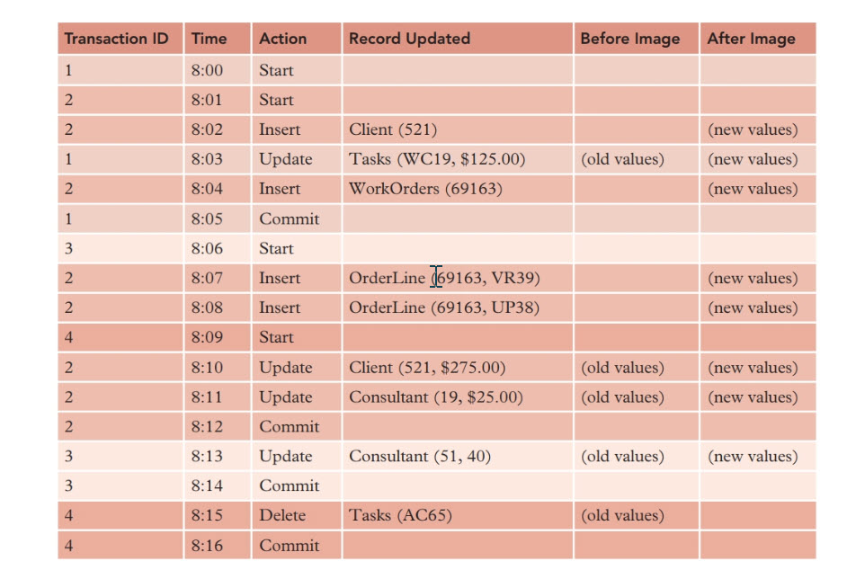

If one of the transactions are interrupted, the DBMS will initiate backward recovery or rollback in order to correct the database. Rollback is accomplished by “reading the log for the problem transactions and applying the before images to undo their updates” until the last commit or save point (Starks et al, 2018).

If transactions 2 is interrupted at 8:10, the DBMS will rollback all this transaction, as well as all the transactions that occurred before the last “Commit” that took place at 8:05. Thus, the transactions that will be rolled back as follows:

* Transaction that occurred at 8:10 – Client (521, $275.00)
* Transaction that occurred at 8:08 – OrderLine (69163, UP38)
* Transaction that occurred at 8:07 – OrderLine (69163, VR39)

1. **Occasionally, users at BITS obtain incorrect results when they run queries that include built-in (aggregate, summary, or statistical) functions. The DBA told management that unrepeatable reads caused the problems. Use books, articles, and/or the Web to research the unrepeatable-read problem. Write a short report that explains the unrepeatable-read problem to management and use an example with your explanation. (Note:**

**Unrepeatable reads also are called inconsistent retrievals, dirty reads, and inconsistent reads.) If you use information from the Web, use reputable sites. Do not plagiarize or copy from the Web.**

The unrepeatable-read problem occurs in database when “two or more read operations of the same transaction” have different or inconsistent values of the same variable, thus giving us an unrepeatable read (Geeksforgeeks, 2019).

For example, a read operation is done in a transaction (to avoid confusion, we will call this transaction “Transaction 1”) that reads the amount of a variable. We will call the variable “Z.” In a different transaction, the value of Z is changed after the initial read operation performed in Transaction 1. After the value of Z has been changed, Transaction 1 initiates another read operation for Z. However, the results for this read operation do not match the results from the previous read operation. The result is not repeated, and the data is inconsistent (Geekforgeeks, 2019).

1. **You have explained replication to management, and some managers ask you for examples of when replication could be useful to them. Describe two situations, other than the ones given in the text, when replication would be useful to an organization.**

By using replication we can ensure that all the original data from the master database remains intact. For example, a replica of the master database is given to a user who is working remotely. The user may not be very experienced with manipulating databases, and some of the updates he makes on his replica will create inconsistencies and redundancy if his replica is synchronized with the master database. Before synchronization occurs, the changes the user tried to make in his replica can be reviewed.

Another scenario of why replication can be useful is if replicas of the master database are given to users to work on, and a major catastrophe causes the data on the master database to be lost. Luckily, replicas were made of the database so any lost data can be easily recovered.

1. **The staff of the marketing department at BITS is scheduled to receive some statistical databases, and they need you to explain these databases to them. (A statistical database is a database that is intended to supply only statistical information to users; a census database is an example of a statistical database.) Using a statistical database, users should not be able to infer information about any individual record in the database. Use books, articles, and/or the Web to research statistical databases; then write a report that explains them, discusses the problem with using them, and gives the solution to the problem.**

There are two different types of statistical databases: a pure statistical database and an ordinary database with statistical access (Stallings, 2007). In a pure statistical database, the database only stores statistical data, thus using the data to try and infer confidential individual information would be next to impossible (Stallings, 2007).

The problems with inference arise from the use of an ordinary database with statistical access. With this type of statistical database, the database contains individual entries, and each individual entity may contain a person’s confidential information (Stallings, 2007). Users are only permitted to make statistical queries (Stallings, 2007). However, problems may arise when users may infer confidential information about a person through the deduction of certain attributes (Stallings, 2007).

In order to combat inference, two approaches are generally used: query restriction and perturbation (Stallings, 2007). With query restriction, the DBMS will reject any queries “that can lead to a compromise” (Stallings, 2007). One example of a query restriction is a DBMS not allowing users to access any query set that has only a few records (Stallings, 2007). With perturbation, the user will be provided answers to all their queries, but the answers will be approximations (Stallings, 2007). An example of perturbation is when the data in a statistical database is modified in order “to produce statistics that cannot be used to infer values of individual records” (Stallings, 2007).

1. **The DBA at BITS wants you to investigate biometric identification techniques for potential use at the company for computer authentication purposes. Use books, articles, and/or the Web to research these techniques, then write a report that describes the advantages and disadvantages of each of these techniques. In addition,**

**recommend one technique and provide a justification for your recommendation.**

Biometrics is an authentication technique that “identifies users by physical or behavioral characteristics such as fingerprints, voiceprints, handwritten signatures, and facial characteristics” (Starks et al, 2018). Perhaps the greatest advantage of using biometric identification is that it is more secure than the more traditional forms of authentication “such as text-based passwords, PIN numbers, and personal security questions” (Botezatu, 2018).

Using biometric authentication may have some drawbacks, however. Employees may feel the requirement to give the company biometric data crosses the line and is an invasion of their privacy (Korolov, 2019). These concerns by employees are legitimate, as stolen biometric data by a bad actor can have serious and lasting consequences to the individual. Another major disadvantage to biometric authentication is the initial cost (Korolov, 2019).

I recommend use a two-factor approach to authentication. The first layer of security may come from a password or an ID scan. The second layer should use biometric authentication. In particular, fingerprint scanning should be used. I recommend this option because fingerprint scanning has become the most common type of biometric authentication used by enterprises (Korolov, 2019). Due to the now ubiquitous nature of fingerprint scanners, fingerprint scanning will probably also be the most affordable option for biometric authentication. Using a fingerprint scan as an added layer of authentication will present the organization with a greater level of security without breaking the bank.

1. **Because most consultants access the BITS database from their mobile devices, such as smart phones and tablets, the DBA is considering the potential use of cloud computing. Use books, articles, and/or the Web to research cloud computing, then write a report that describes the advantages and disadvantages of making data available in the cloud. If you use information from the Web, use reputable sites. Do not plagiarize or copy from the Web.**

Cloud computing is becoming more common throughout the business world, and for good reason. One advantage of using cloud computing is data recovery (Edmonson, 2021). By using the cloud, a company will not have to worry about backups, as most cloud service providers create backups of the data automatically (Edmonson, 2021). This is particularly useful if there were to be a disaster, as the company will not have to pay large sums of money for data retrieval (Edmonson, 2021). A second advantage of cloud computing is that it is scalable and very cost-effective (Edmonson, 2021). With cloud computing, the organization would only have to pay for the amount of storage they need (Edmonson, 2021). This storage can also help to mitigate the large expenses that come with storing the data in house, such as the cost of hardware, maintenance, updates, and software licenses (Edmonson, 2021).

Though cloud computing may sound like a magic bullet to many of the organization’s problems, there are some disadvantages. For one, there will be additional security and privacy concerns by using cloud computing (Edmonson, 2021). This is due to the fact that we will be giving the data we use of a third party, and the misuse of data by a third party is not unheard of (Edmonson, 2021). Next, in order to use the cloud we must be connected to the internet at all times (Edmonson, 2021). If for some reason we unable to connect to the internet, workflow could potentially come to a standstill. The third disadvantage of using cloud computing is that if we decide that we like using the cloud but would like to switch providers, data migration to the new provider could be extremely difficult (Edmonson, 2021).

References

Botezatu, B. (2018, July 24). More organizations are adopting biometrics for security-but barriers still remain. Retrieved April 11, 2021, from https://businessinsights.bitdefender.com/more-organizations-are-adopting-biometrics-for-security-but-barriers-still-remain

Edmondson, J. (2021, January 4). Pros and cons of cloud storage: Is cloud storage right for your data? Retrieved April 11, 2021, from https://www.businesstechweekly.com/operational-efficiency/cloud-computing/pros-and-cons-of-cloud-storage/

GeeksforGeeks. (2019, August 23). Concurrency problems in DBMS Transactions. Retrieved April 11, 2021, from https://www.geeksforgeeks.org/concurrency-problems-in-dbms-transactions/

Korolov, M. (2019, February 12). What is Biometrics? 10 physical and behavioral identifiers that can be used for authentication. Retrieved April 11, 2021, from https://www.csoonline.com/article/3339565/what-is-biometrics-and-why-collecting-biometric-data-is-risky.html

Stallings, W. (2007, August 17). Computer security and statistical databases. Retrieved April 11, 2021, from https://www.informit.com/articles/article.aspx?p=782117

Starks J. L., Pratt P. J., & Last M. Z. (2018). *Concepts of Database Management*. [VitalSource

Bookshelf]. Retrieved from https://online.vitalsource.com/#/books/9780357246856/